City Guide App

# Introduction

This application shows the city names in the list. When user selects city, it shows the information to the user. The city names and information is scalable. To implement this application, I used phone gap technology.

Adobe’s PhoneGap platform enables a developer to create an app that runs on a variety of mobile devices. The developer accomplishes this largely by writing the user interface portion of their application with Web technologies such as HTML, CSS and JavaScript. PhoneGap’s development tools then bundle the HTML, CSS and JavaScript files into platform-specific deployment packages. PhoneGap supports a wide variety of platforms

# Implementation

Since this is prototype application, the city names were hard coded in the HTML page. I used JQuery accordion UI plugin to show the information.

The app screen shots were shown below

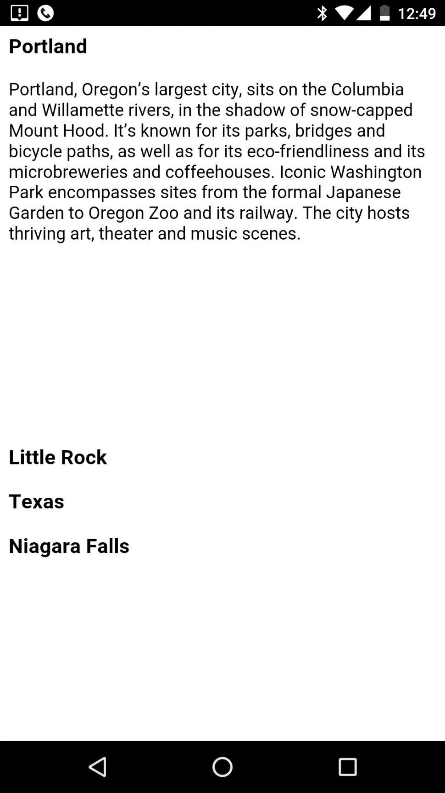

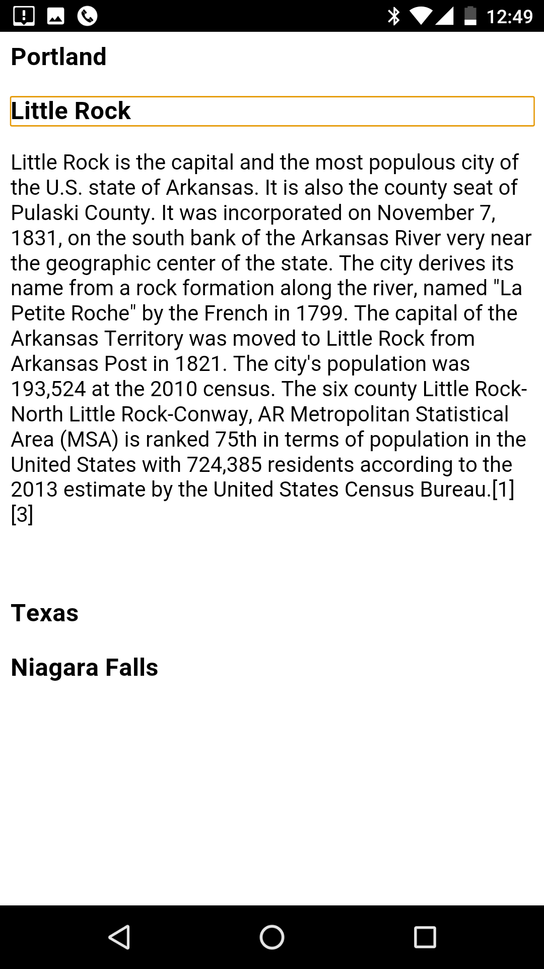

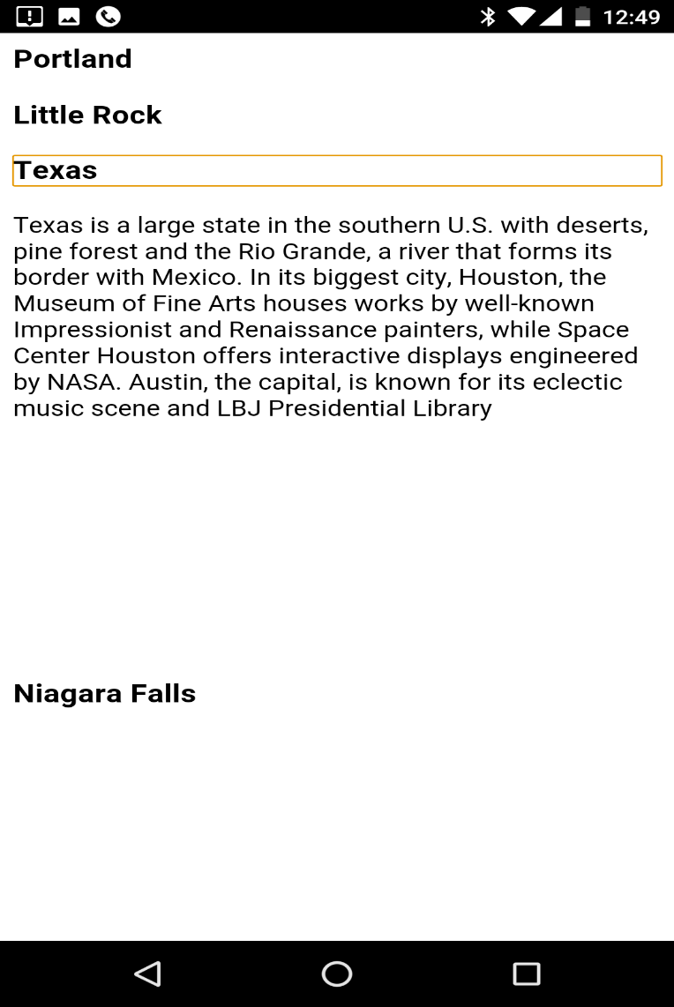

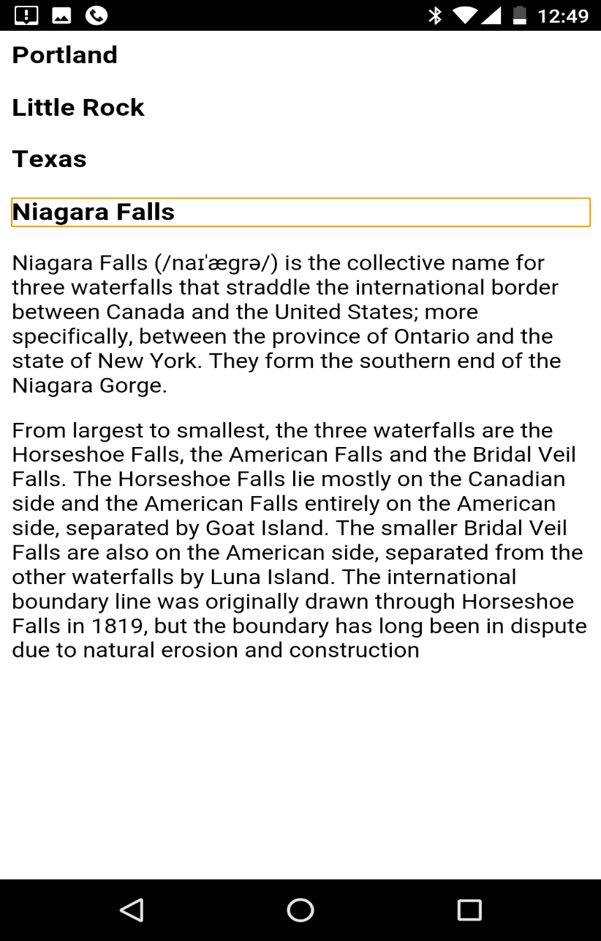

# References

1. <https://www.smashingmagazine.com/2014/02/four-ways-to-build-a-mobile-app-part3-phonegap/>